How to connect to kafka/eventstreams using ACE

## Use case:

* Save JSON data from a rest api to event streams

## Steps

1. Create a topic in Event Streams and download the certificate

2. Create an ace flow - Flow to save data to EventStreams using rest api

3. Deploy the bar file on CP4I and generate a secret

4. Test

## 1. EventStreams

1. Click on “Create a topic” and name "ace". Select 3 partitions and leave rest the default.

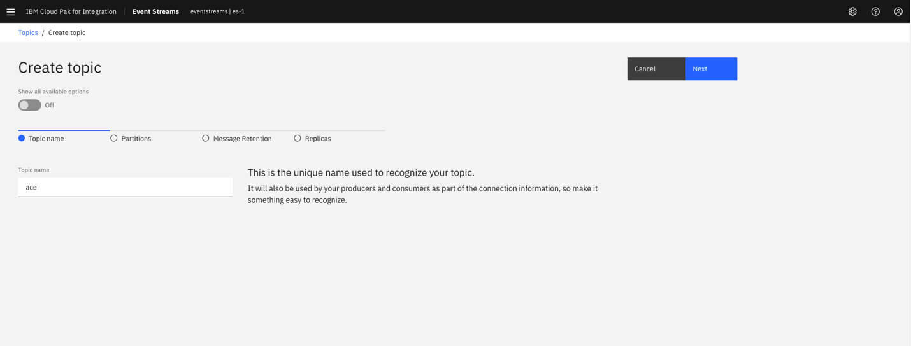

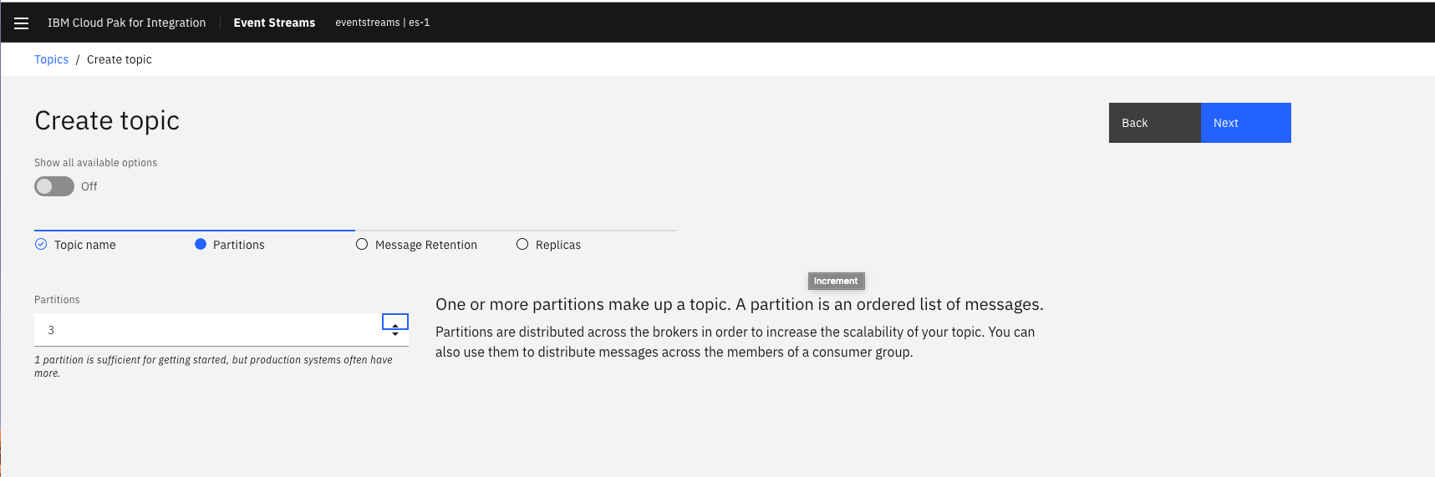

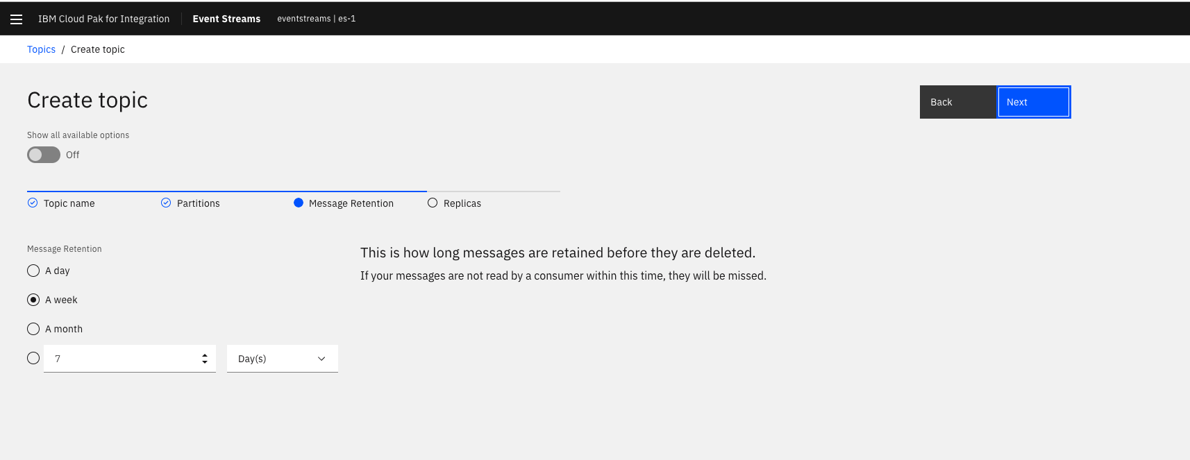

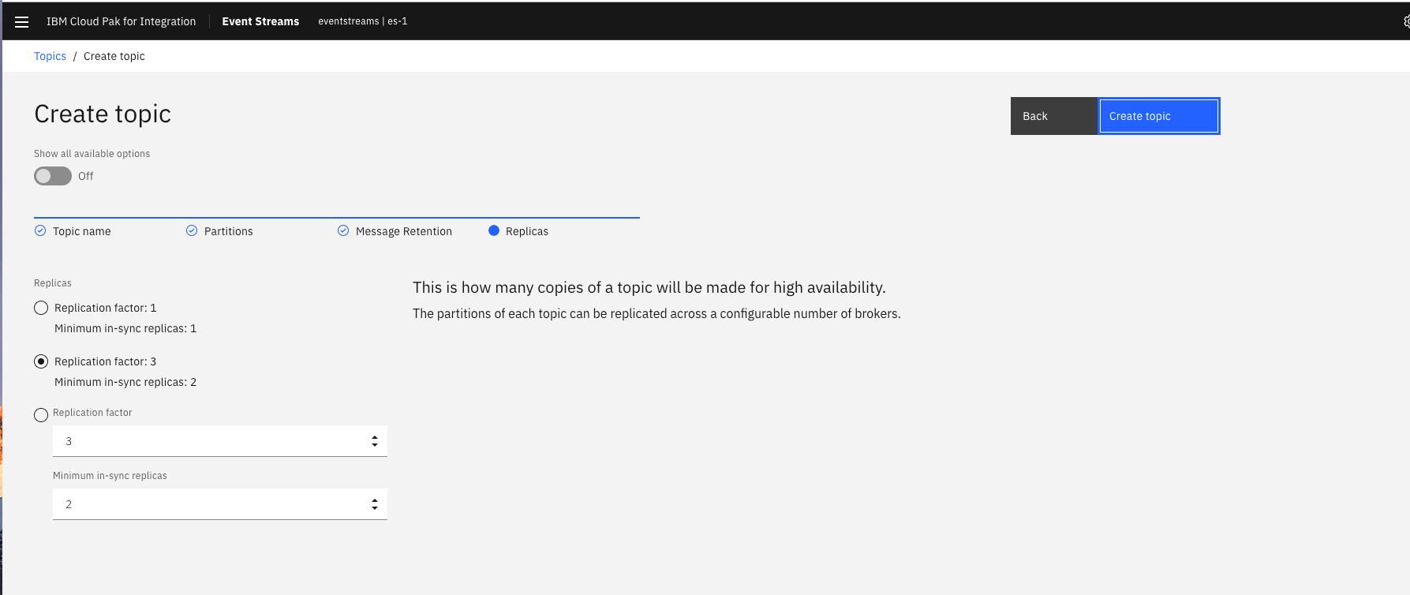

2. Click on the “connect to this topic” -> Generate API Key

Create an api with the name "ace_api" and DOWNLOAD JSON.

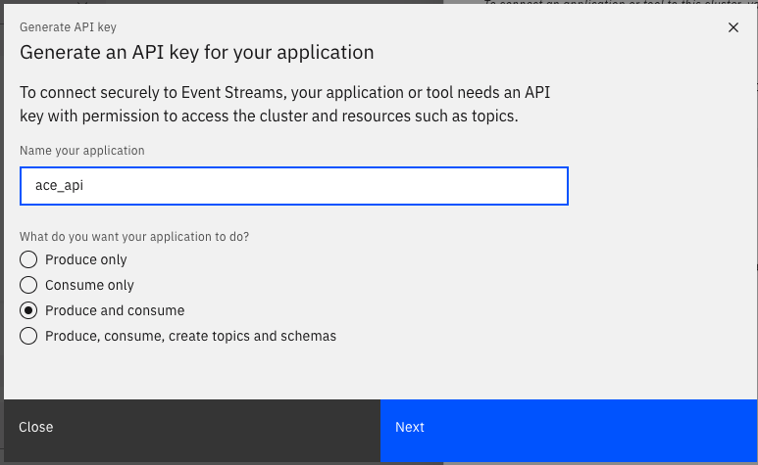

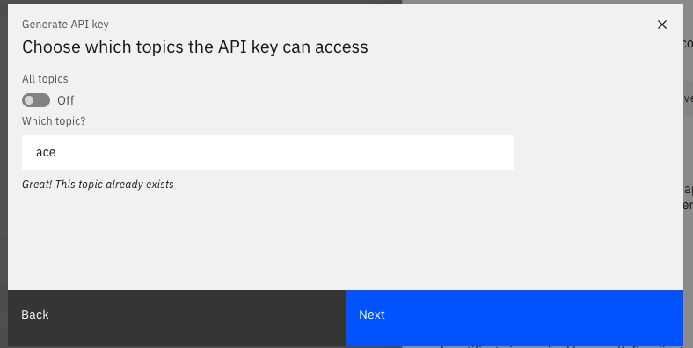

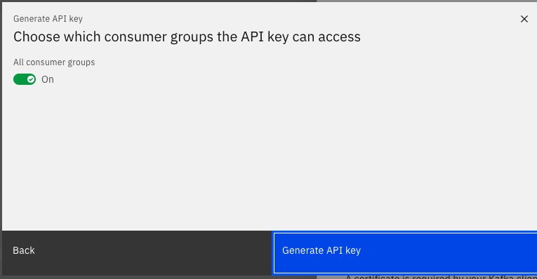

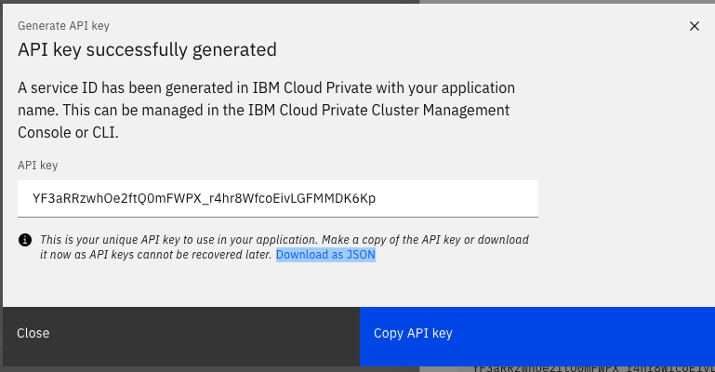

3. Download Java truststore file

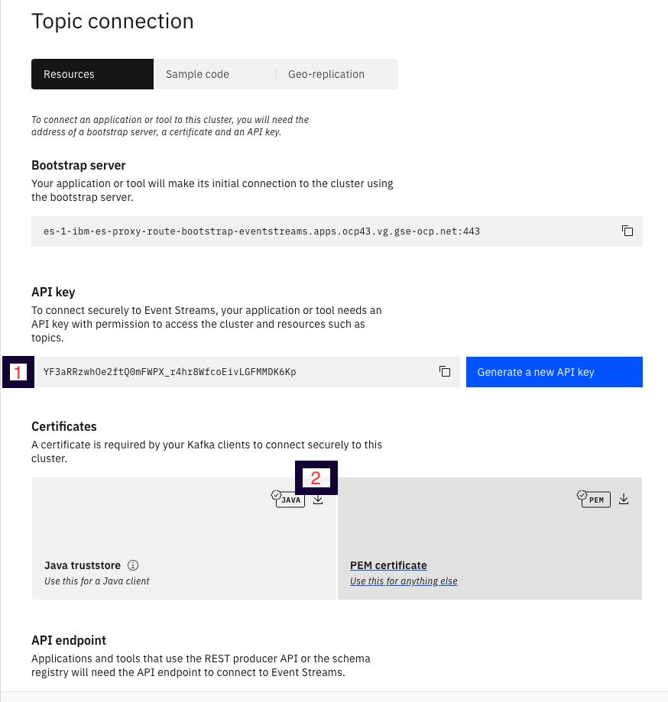

## 2. ACE flow in the toolkit

1. Create a Rest API project by clicking File -> New -> REST API and Name the project as "Example"

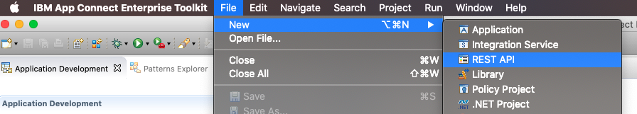

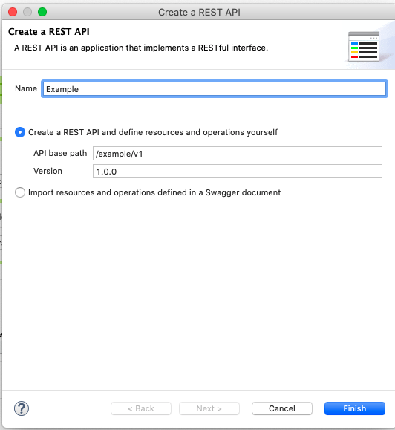

2. Click on "+" under Resources and select POST and name the path as "producer"

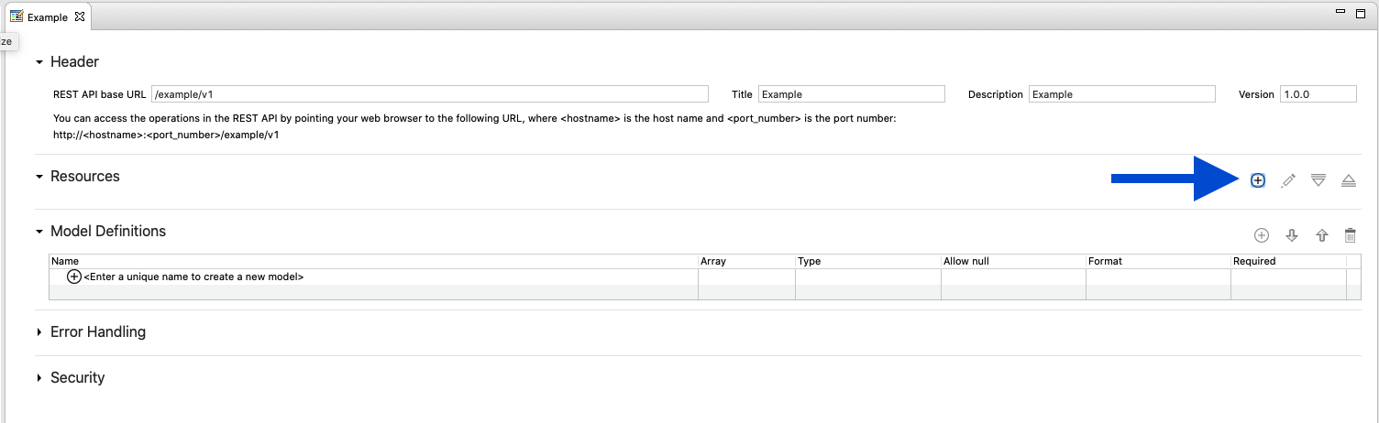

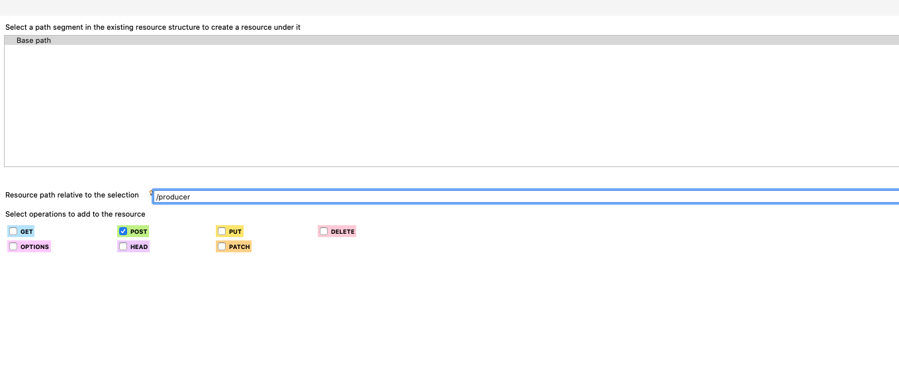

3. Save

4. Click on the button below to add a subflow 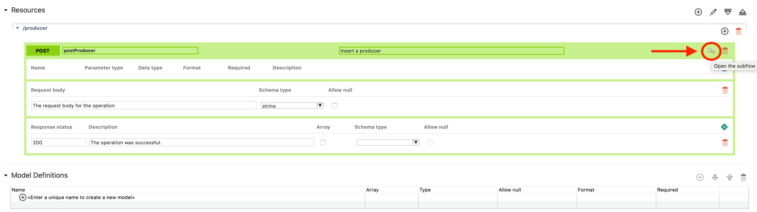

4. Add subflow and the following nodes

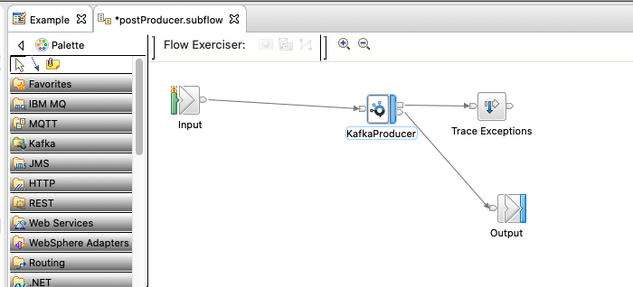

“Out” from kafkaProducer node should go to output

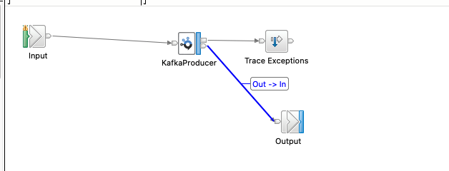

“Failure” from kafkaProducer node should go to Trace Exceptions!

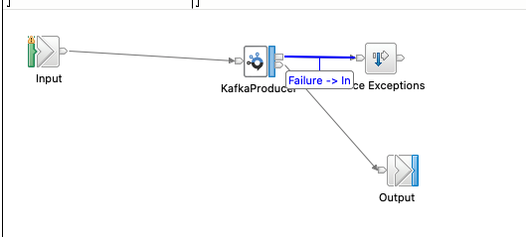

Click on KafkaProducer -> Under Properties -> Select Basic and fill in your information.

For example:

* Topic Name: ace
* Bootstrap servers: es-1-ibm-es-proxy-route-bootstrap-eventstreams.apps.ocp43.vg.gse-ocp.net:443

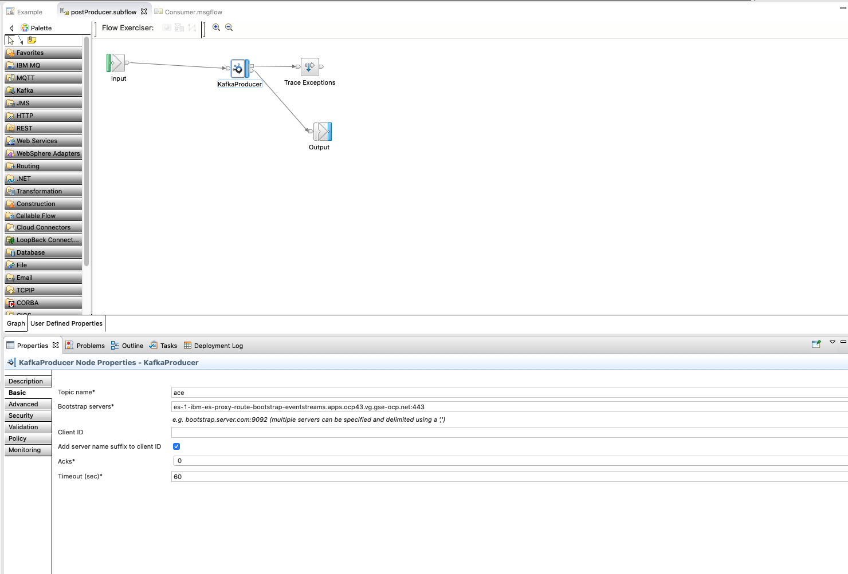

Under Security

* Security Protocol: Select SASL_SSL
* SSL protocol: TLSv1.2

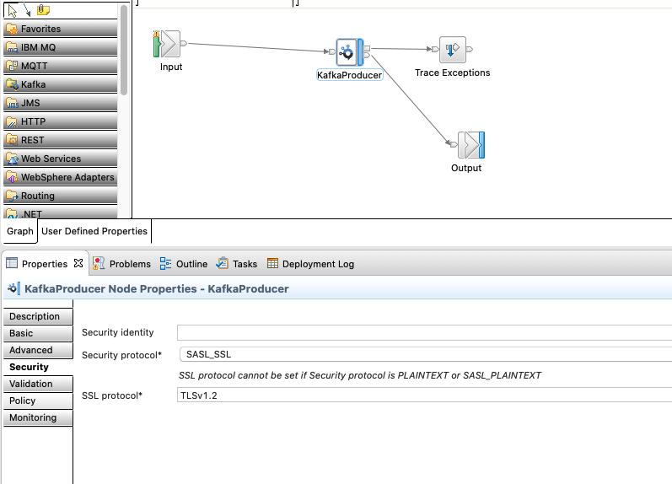

4. Configure Trace Exceptions as below

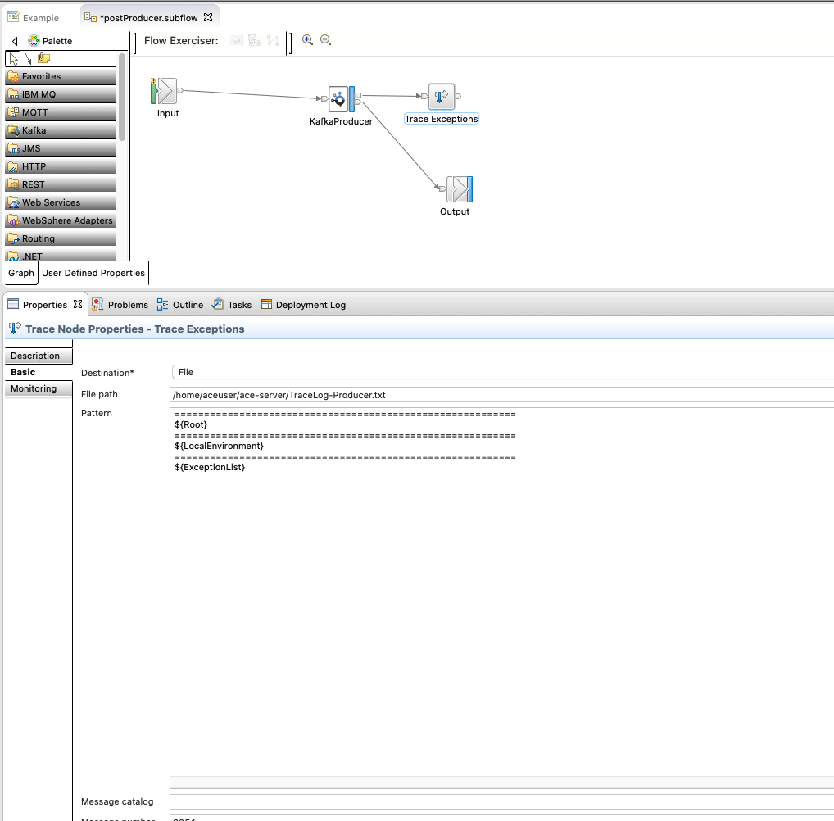

5. Save

SAVE THE FLOW AS A BAR FILE

File -> NEW -> BAR File

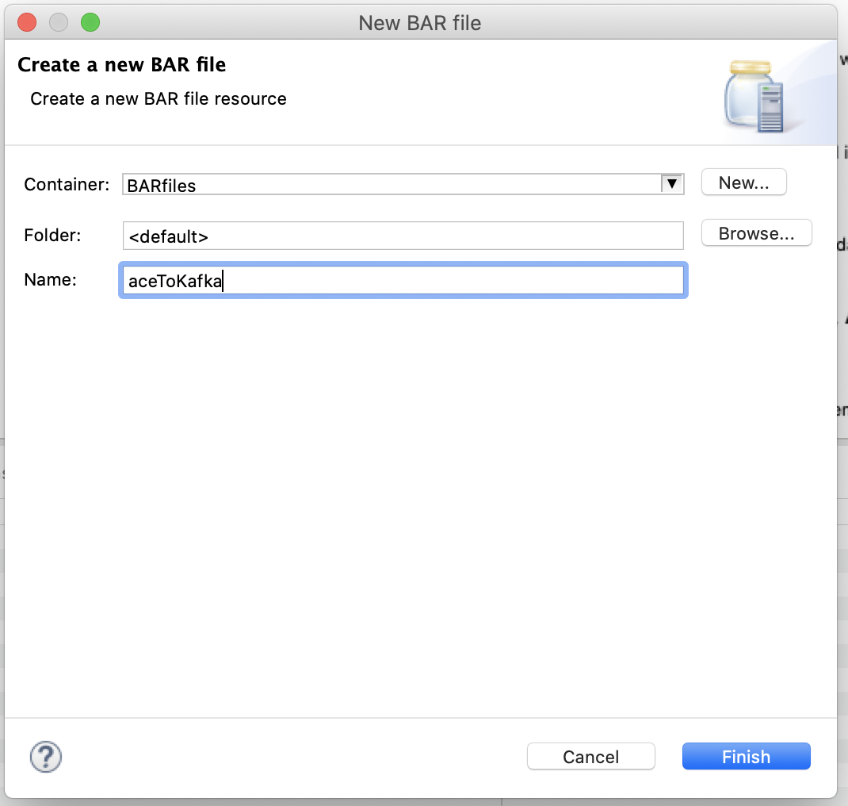

Name it as "aceToKafka" and click Finish

* Select your project “Example”
* Select Compile and in-line resources
* Build and Save

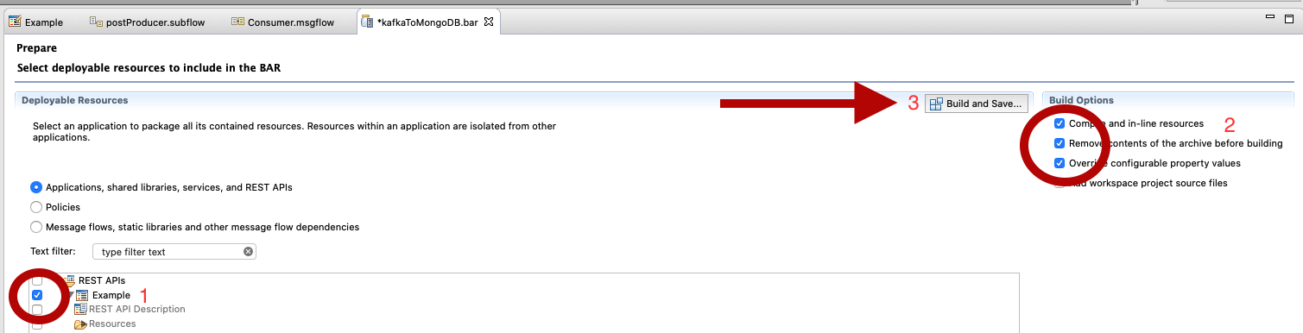

## 3. Deploy the bar file on CP4I

Go to your CP4I ace dashboard

1. Click Create Server -> Click Add a bar file

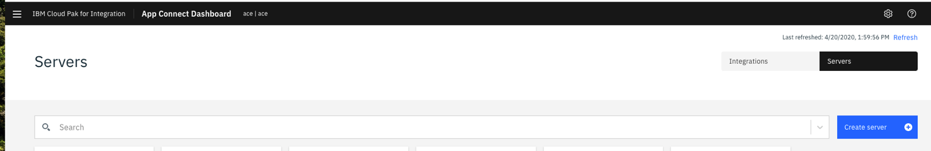

Go to your workspace -> BARfiles -> Select kafkaToMongoDB.bar -> Click Continue

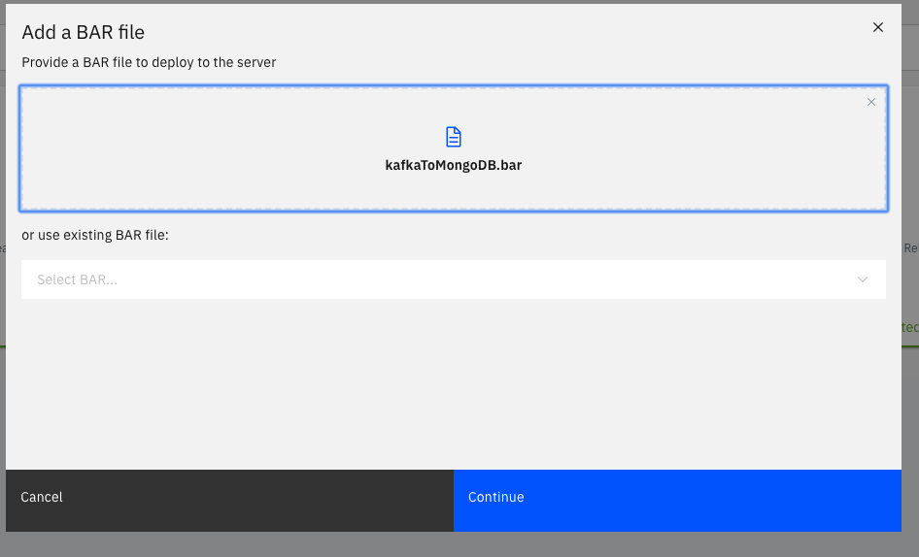

2. Download configuration package on your desktop

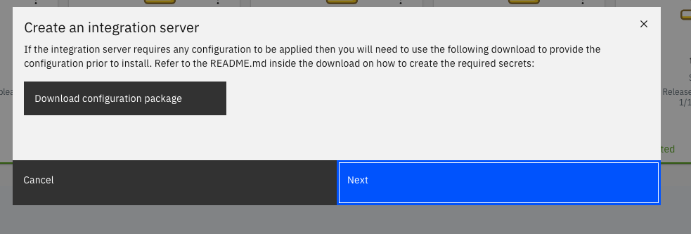

3. Open the config.tar.gz

Move the java truststore file (es-cert.jks) and api key (es-api-key.json) here.

4. Run

keytool -list -storetype JKS -keystore es-cert.jks -storepass password -v

To show the content of the jks file (password is password)

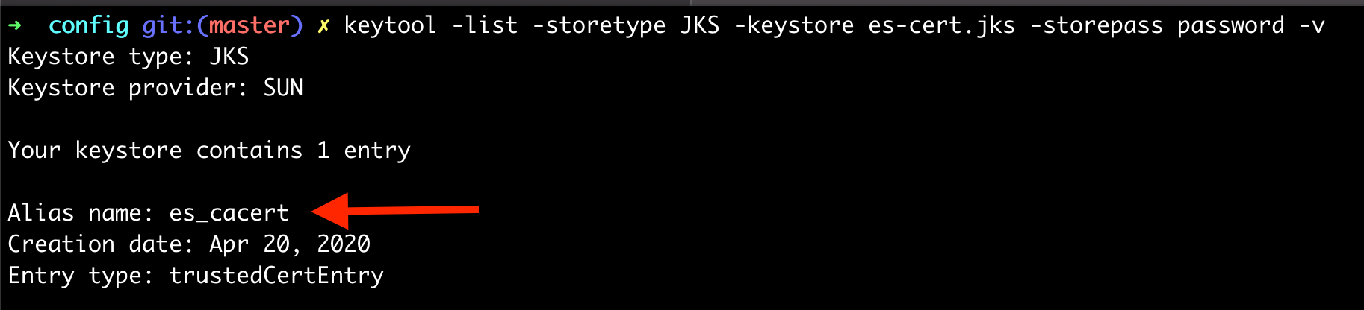

Get the alias name from the above output

Use that alias to run the below command:

keytool -export -alias es_cacert -file truststoreCert-mykey.crt -keystore es-cert.jks



5. Open truststorePassword.txt in the config folder. Add your truststore password:

password

Save

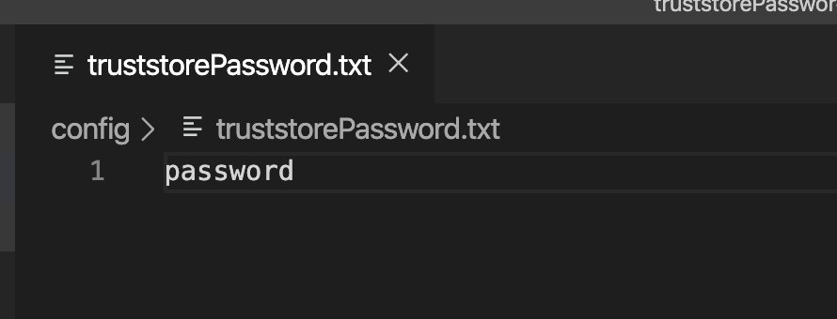

6. Open setdbparms.txt and add the following:

kafka::KAFKA token <api_key>  
IntSvr::truststorePass thisispwdfortruststore password

* Make sure you keep the text “thisispwdfortruststore” exactly how it is mentioned above. The text “thisispwdfortruststore” is a placeholder. Since we are using truststore certificate we don’t need to pass in username so instead we are using random text as a placeholder.

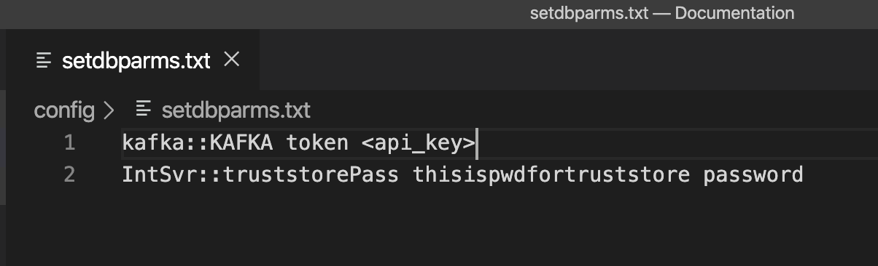

Copy the api_key from the es-api-key.json and paste next to token

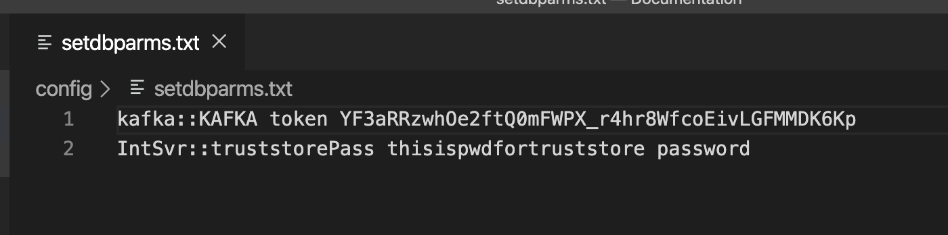

7. Open serverconf.yaml and add following:

---  
ResourceManagers:  
 JVM:  
 truststoreType: 'JKS'  
 truststoreFile: '/home/aceuser/ace-server/truststore.jks'  
 truststorePass: 'IntSvr::truststorePass'

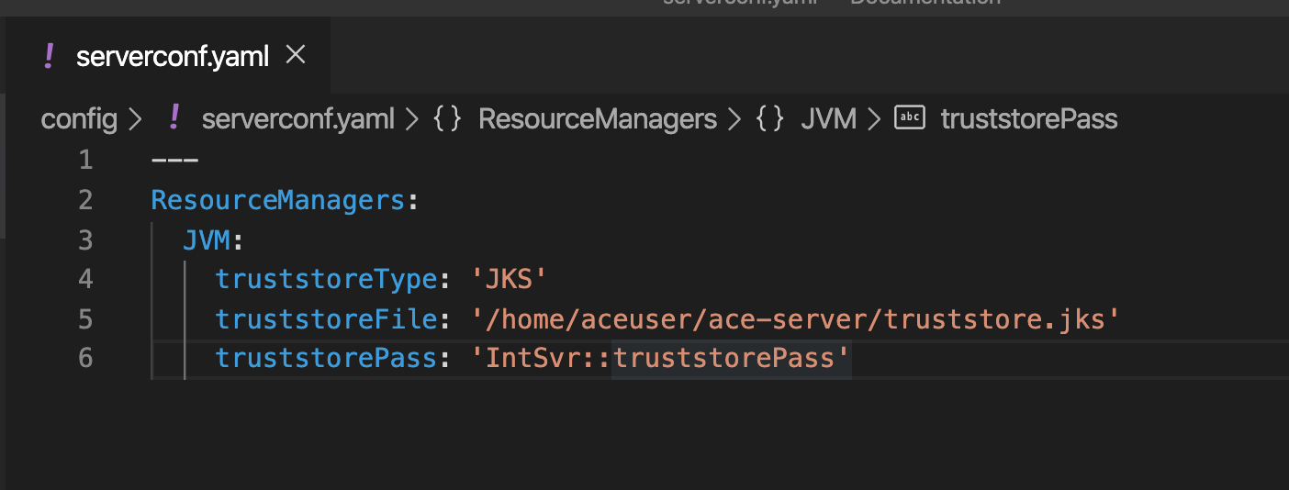

——————- Important ——————–

RENAME serverconf.yaml to server.conf.yaml

——————- Important ——————–

8. Create a secret - Go to openshift and copy the login command - Login to openshift through command line - Go to the “config” directory through command line

Make sure you are in the same namespace/project as your deployed ACE Dashboard and your custom image.

RUN ./generateSecrets.sh <secret-name>

For example,

oc project ace  
  
./generateSecrets.sh ace-kafka-secret

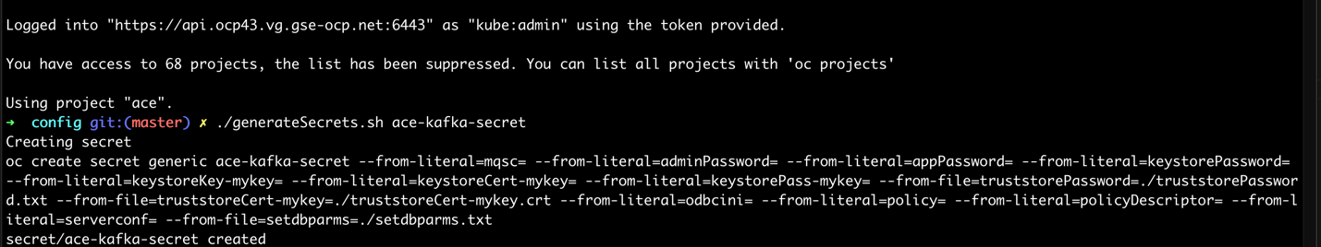

Go back to CP4I

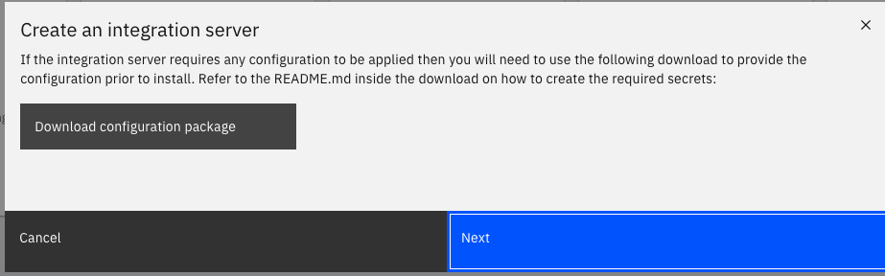

Select Toolkit and click Next

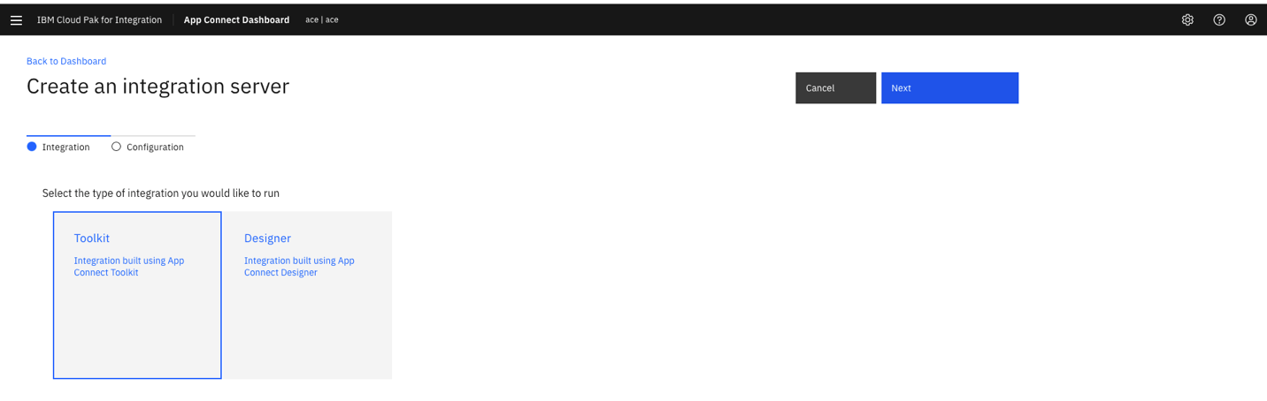

* Name: ace-kafka
* Turn show everything option to ON
* Uncheck production usage

Image pull secret – the secret that was created during the installation of ace

cp-entitlement



* Name of the secret that contains the server configuration: ace-kafka-secret

List of key aliases for the keystore: mykey

* List of certificate aliases for the truststore: mykey
* And leave rest the default

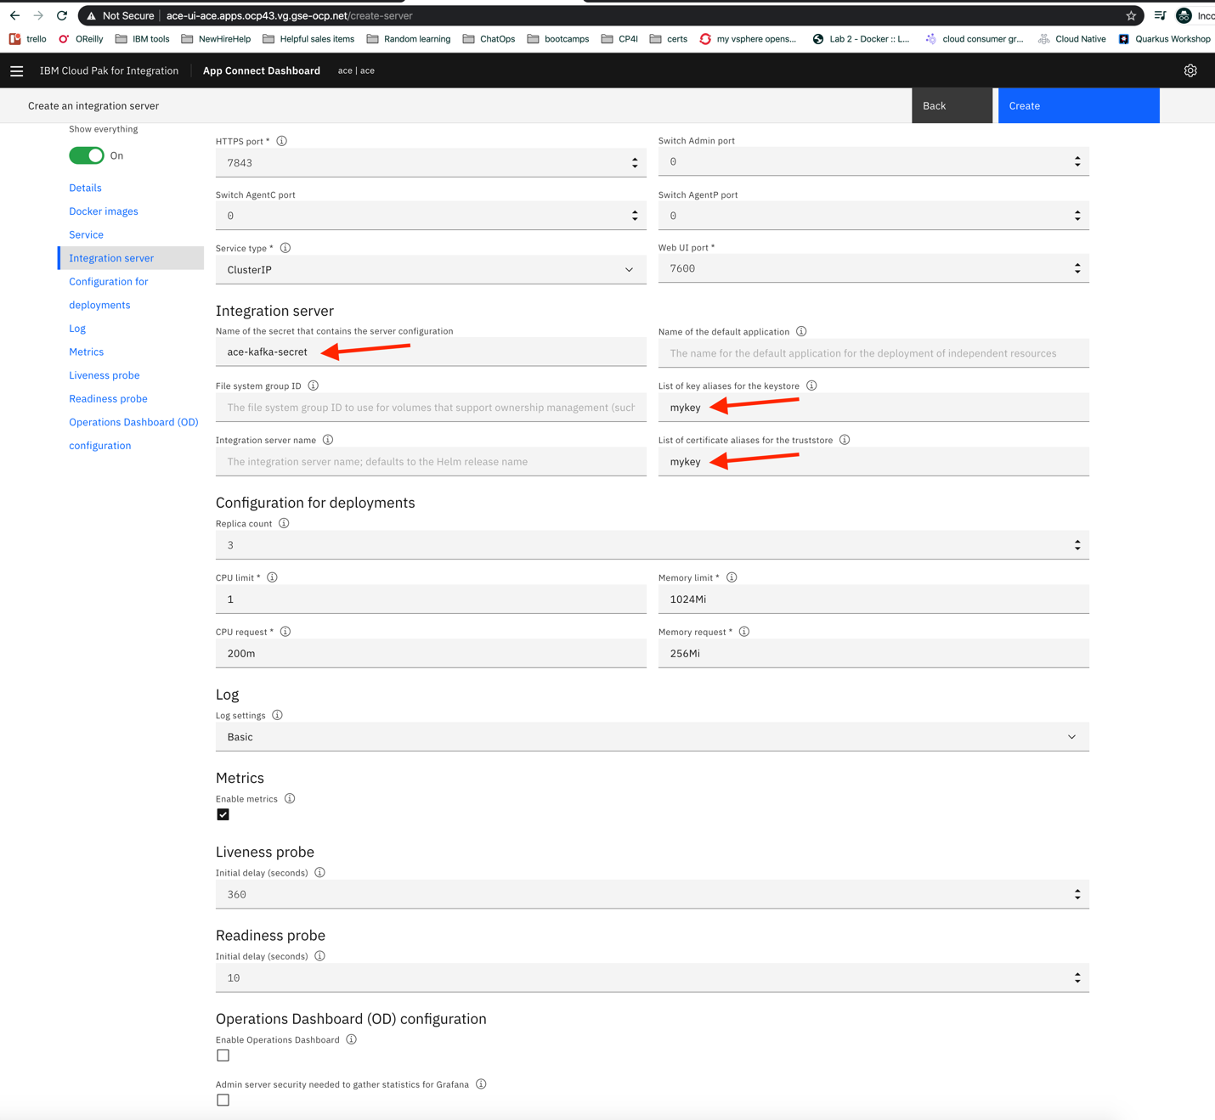

## 4. Test

Open the server named kafkamongodb on ace dashboard and get the URL

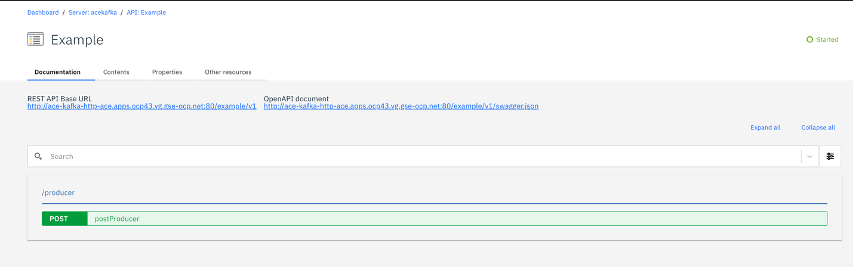

create data.json with the following:

{"hello":"world"}

curl -X POST <base url>/producer -d @data.json  
  
Example:  
curl -X POST <http://ace-kafka-http-ace.apps.ocp43.vg.gse-ocp.net/example/v1>/producer -d @data.json

or you can test using postman

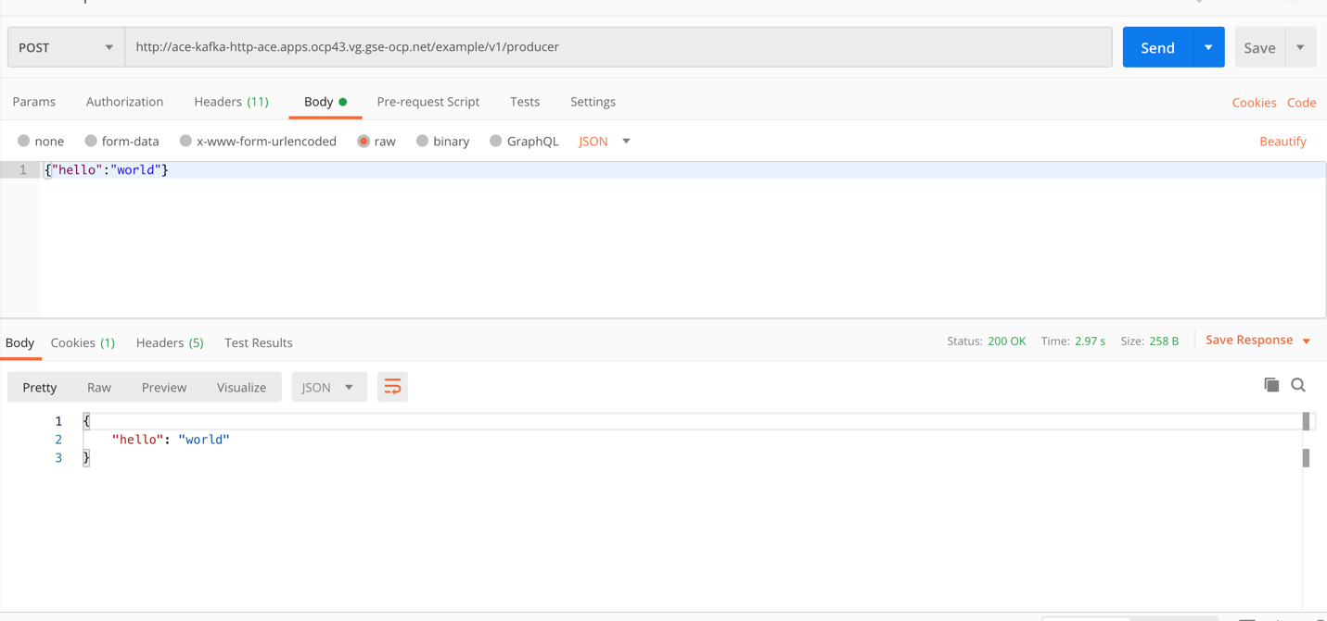

You can see the message in your event streams topic

